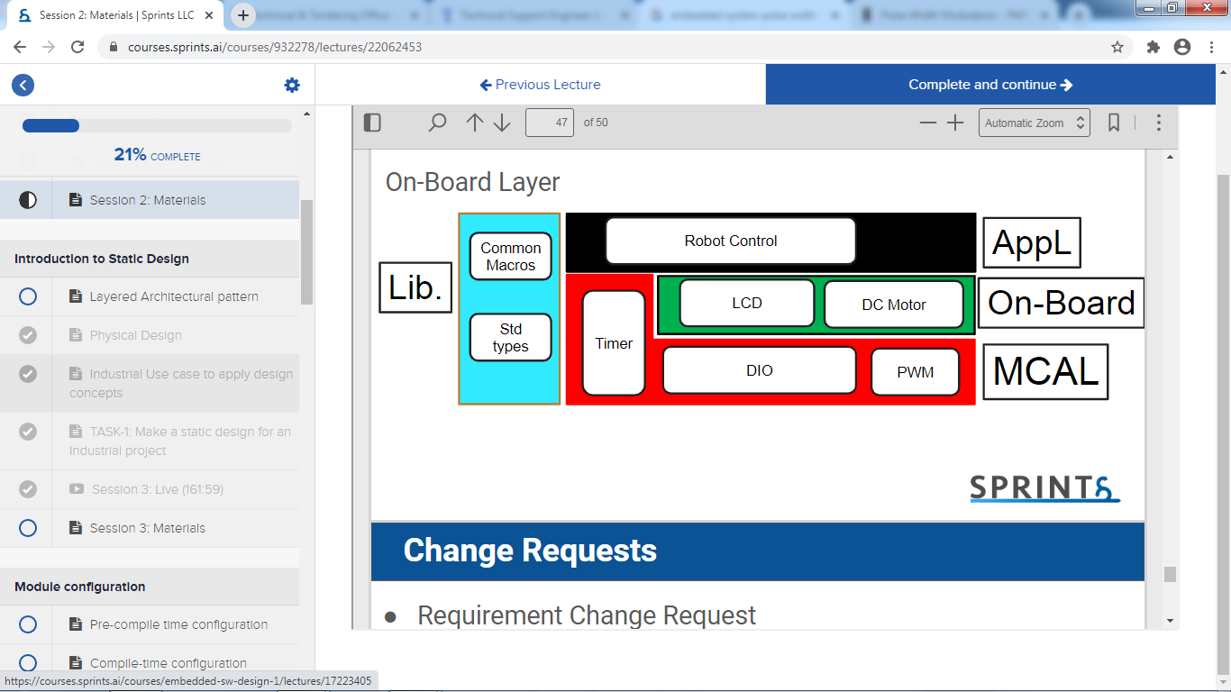

LCD robot control:

|  |  |  |
| --- | --- | --- |
|  | LCD robot control: | API _name |
|  |  |  |
|  | Sensor_value float | inputs |
|  | Direction/int speed char | Output |
|  | 1 | E_OK |
|  | 0 | E_NOK |
|  |  |  |
|  |  |  |

DC MOTOR_ PWM control:

|  |  |  |
| --- | --- | --- |
|  | DC MOTOR PWM: | API _name |
|  |  |  |
|  | freq_value/duty cycle int | inputs |
|  | Speed value int | Output |
|  |  |  |
|  | 1 | E_OK |
|  | 0 | E_NOK |
|  |  |  |

:

DC MOTOR_DIO :

|  |  |  |
| --- | --- | --- |
|  | DC MOTOR_DIO | API _name |
|  |  |  |
|  | Float Sensor_value | inputs |
|  | Char direction/ int speed | Output |
|  |  |  |
|  | 1 | E_OK |
|  | 0 | E_NOK |
|  |  |  |

robot control:

|  |  |  |
| --- | --- | --- |
|  | LCD robot control: | API _name |
|  |  |  |
|  | Sensor_value | inputs |
|  | direction | Output |
|  |  |  |
|  |  |  |
|  |  |  |
|  |  |  |

DC motor PWM :

|  |  |  |
| --- | --- | --- |
|  | robot control: | API _name |
|  |  |  |
|  | Float Sensor_value | inputs |
|  | Char | Output |
|  |  |  |
|  |  |  |
|  |  |  |
|  |  |  |

LCD direct_control:

LCD robot control:

|  |  |  |
| --- | --- | --- |
|  | LCD robot control: | API _name |
|  |  |  |
|  | Float Sensor_value | inputs |
|  | Char | Output |
|  |  |  |
|  |  |  |
|  |  |  |
|  |  |  |

LCD robot control:

|  |  |  |
| --- | --- | --- |
|  | LCD robot control: | API _name |
|  |  |  |
|  | Sensor_value | inputs |
|  | direction | Output |
|  | 0 | E_OK |
|  | 1 | E_NOK |
|  |  |  |
|  |  |  |

LCD robot control:

|  |  |  |
| --- | --- | --- |
|  | LCD robot control: | API _name |
|  |  |  |
|  | Sensor_value | inputs |
|  | Speed value | Output |
|  |  |  |
| 1 | E_OK | Return |
|  | E_NOK |  |
|  |  |  |

:

H_bridge robot control:

|  |  |  |
| --- | --- | --- |
|  | LCD robot control: | API _name |
|  |  |  |
|  | Float Sensor_value | inputs |
|  | Char direction | Output |
|  |  |  |
|  |  |  |
|  |  |  |
|  |  |  |

LCD robot control:

|  |  |  |
| --- | --- | --- |
|  | LCD robot control: | API _name |
|  |  |  |
|  | Sensor_value | inputs |
|  | direction | Output |
|  |  |  |
|  |  |  |
|  |  |  |
|  |  |  |

LCD direct_control:

LCD robot control:

|  |  |  |
| --- | --- | --- |
|  | LCD robot control: | API _name |
|  |  |  |
|  | Float Sensor_value | inputs |
|  | Char | Output |
|  |  |  |
|  |  |  |
|  |  |  |
|  |  |  |

LCD direct_control:

LCD robot control:

|  |  |  |
| --- | --- | --- |
|  | H bridge DIO | API _name |
|  |  |  |
|  | Char direction | inputs |
|  | Char direction | Output |
|  |  |  |
|  |  |  |
|  |  |  |
|  |  |  |